Contents

- Introduction......................................................................................................1
1.1 Digital Filters................................................................................................1
1.2 Objective.........................................................................................................1

2. Background Information...........................................................................1
2.1 Theory of Digital Filters.........................................................................1
2.2 Types of Digital Filters ...........................................................................3
2.3 Finite Impulse Response Filters.............…..........................................4
2.4 Infinite Impulse Response Filters........................................................5
2.5 Implementation of Digital Filters.........................................................5

3. Design Overview....................…….................................................................7

4. Equipment Used.............................................................................................7
4.1 Software........................................................................................................8
4.2 Hardware......................................................................................................8
4.2.1 The TMS320C30 Digital Signal Processor....................................8
4.2.2 The TMS320C30 Card.......................................................................9

5. System Design......................................................………………..................10
5.1 Entering the Filter Specification.........................................................12
5.2.1 Specification of a FIR Filter............................................................12
5.3.2 Specification of an IIR Filter...........................................................19
5.2 Calculation of the Filter Coefficients.................................................22
5.2.1 Calculation of FIR Coefficients .................................................22
5.2.2 Calculation of IIR Coefficients .................................................27
5.3 Display of Frequency Response Graph.............................................30
5.3.1 Display of a FIR Filter Frequency Response Graph....................30
5.3.2 Display of an IIR Filter Frequency Response Graph...................36
5.4 Implementation of Filtering.................................................................38
5.4.1 FIR Implementation..........................................................................38
5.4.2 IIR Implementation...........................................................................39

6. Results.......................................................................................................….....41

7. Future Development………………………………………………….….41

8. Conclusion......................................................................................................42

9. References......................................................................................................43
1. Introduction

The need for filtering arises when the signal of interest is mixed with interfering signals or noise. The noise may be introduced by the channel or the electronic components and many times results to severe distortion of the signal.

In the past, analogue filters were the primary means to performing the necessary filtering to separate the signal from the noise components. In some cases, the design of multipole analogue filters required a number of relatively large components to achieve the required degree of filtering. The resulting filter was susceptible to minor variations in component values and often required additional amplifiers to perform buffering. The stability of these amplifiers required a reasonable degree of analysis, which might be offset using cookbook designs and simulation software. Predicting the response of these filters to all variations and scenarios was difficult and time consuming.

Since the advent of inexpensive processing power the general engineering community has had opportunity to apply digital filtering techniques to signal processing applications. Filter functions that were not realisable in analogue implementations came into practicality. Filters with very steep cut-off or very narrow notches could be realised by software implementations. An amazing amount of signal to noise improvement became attainable with systems having spectrally separated and unique signal components. As digital filtering became more and more popular, unique integrated circuit chipsets and processors were developed to provide high speed and compact implementations. Complementary design tools were developed to speed development time and simplify the necessary software coding requirements [1-5].

1.2 Objective

The aim of the project is to develop a programmable real time digital filter for laboratory use. The digital filter will offer a variety of different frequency responses and cut-off rates. The filter will be implemented in real time on a "third generation" DSP floating point microprocessor. The microprocessor, which is known as the TMS320C30, resides on a card in a host PC. The user will be able to interface with the PC, by entering a filter specification. The PC will display the frequency response graph on the screen, and if the user is satisfied with it, the program will calculate the required filter coefficients, generate the required necessary assembly code and download it to the TMS320C30 card. The system could implement both FIR and IIR digital filters, and should be convenient to use.

2. Background Information

2.1 Theory of Digital Filters

Digital filtering is concerned with the manipulation of discrete data sequences to remove noise, extract information, separate two or more signals, and change the waveshape, amplitude-frequency and/or phase-frequency characteristics of a signal in a desired manner. A digital filter is a mathematical algorithm implemented in hardware and/or software that operates on a digital input signal to produce a digital output signal for the purpose of achieving a filtering objective.

Digital filters play a very important roles in digital signal processing (DSP) and are preferred compared to their analogue counterparts in a number of applications e.g. data compression speech and image processing because of the following advantages.

- Digital filters can have characteristics that are not possible with analogue filters, such as linear phase response.

- The frequency response of a digital filter can be adaptive where the parameters of the filter are variable and can be adapted to the characteristics of the input signal.

- The characteristics of a digital filter do not vary with environmental changes and ageing so the need for calibration is eliminated.

- Digital filters can have perfect reproducibility.

- The maximum attenuation of an active analogue filter is restricted and is about 60 to 70 dB, whereas digital filters can produce greater attenuation and is only limited by the word length used.

- Digital filters can be used at very low frequencies, where the use of analogue filters is impractical.

Although these advantages, the main disadvantages of digital filters, when compared with analogue filters, are the following.

- The design and implementation of a digital filter can be extremely complex time-consuming and specialised activity.

- The maximum bandwidth of signals that digital filters can handle, in real time, is much lower than for analogue filters. This speed limitation is due to the conversion time of the analogue to digital converter (ADC) and the settling time of the digital to analogue converter (DAC).

- The power requirements of a DSP system, especially using a floating point microprocessor, can be high making them unsuitable for battery powered portable devices.

- Digital filters introduce ADC noise resulting from the quantisation of continuous signals and the round off noise incurred during computation [1].

2.2 Types of Digital Filters

Digital filters are divided into finite impulse response (FIR) and infinite impulse response (IIR) filters. In FIR filters the current output sample, y[n], is a function only of past and present values of the input, whereas in IIR the current output sample, y[n], is a function of past outputs as well as present and past input values. Either type can be represented by its impulse response sequence, h[k], as in figure 1.

h[k], k=0,1,2,3, …
(impulse response)
x[n]
input sequence
y[n]
output sequence

Figure 1. Representation of a digital filter

The input and output signals to the filter are related by the convolution sum and is given by
$y\left[k\right]=\sum_{k=0}^{N−1}{h\left[k\right]⋅x\left[x−k\right]}$
for FIR digital filters

and

$y\left[k\right]=\sum_{k=0}^{N}{a_{k}⋅x\left[x−k\right]}−\sum_{k=1}^{M}{b_{k}⋅y\left[n−k\right]}$
for IIR digital filters

where N, α_{k} and b_{k} is the duration and the coefficients of the filter respectively.

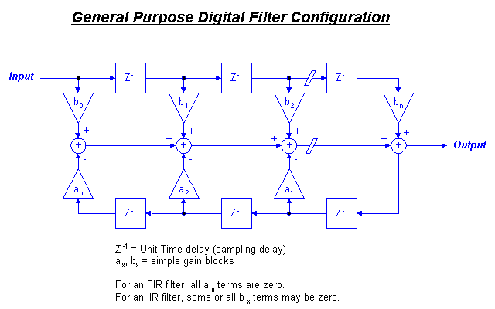
Figure 2 shows the basic structure for a general purpose digital filter. The structure is composed of Z-domain delay blocks, gain stages and summing junctions.

Figure 2. Digital Filter Configuration
The FIR filters have several advantages and disadvantages compared to the IIR filters. In one hand, the main advantages are the following.

- FIR filters can have an exactly linear phase response so that no distortion is introduced into the signal by the filter whereas IIR filters cannot be exactly linear phase.

- Because of the non-recursive nature of the FIR filters, these structures are always stable and round-off as well as overflow errors are easily controlled.

On the other hand, the main disadvantages of the FIR filters are the following.

- IIR filters require fewer coefficients than FIR filters for producing the same attenuation.

- IIR filters are economical in their use of delays, multipliers and adders.

- Analogue filters can be readily transformed into equivalent IIR digital filters meeting similar specifications. This is not possible with FIR filters, as they have no analogue counterpart.

Generally speaking, the choice between FIR and IIR filter depends mainly on the advantages and disadvantages of the two filter types and the type of application that they are to be used in [1].

2.3 Finite Impulse Response Filter Design

Linear phase finite impulse response filters can be designed to meet various filter specifications, such as low pass, high pass, band pass and band stop filtering. For a low pass filter, two frequencies are required, namely, the maximum frequency of the pass band below which the magnitude response of the filter is approximately unity, denoted the pass band corner frequency f_{p}, and the minimum frequency of the stop band above which the magnitude response of the filter must be less than some prescribed level, named the stop band corner frequency f_{s}. The difference between the pass band and stop band corner frequencies is the transition bandwidth. Generally, the order of FIR filter N required to meet some design specification will increase with a reduction in the width of the transition band.

The design of a FIR filter is dealing with the calculation of the required filter coefficient. There are three techniques for coefficient design:

- Windowing

- Optimal approximation

- Frequency sampling

The windowing design method calculates the weighting coefficients by sampling the ideal impulse response of an analogue filter and multiplying these values by a smoothing window to improve the overall frequency response of the filter. The frequency sampling technique samples the ideal frequency specification of the filter and calculates the weighting coefficients by inverse transforming these values. However, better results can generally be obtained with the optimal approximation method. This method is based on the Remez Exchange Algorithm and minimizes the maximum deviation of the magnitude response of the design filter from the ideal magnitude response. The magnitude response of the design filter alternates about the desired specification within the pass band and above the specification in the stop band. The maximum deviation from the desired specification is equalised across the pass and stop bands [2-5].

2.4 Infinite Impulse Response Filter Design

As it was previously stated, in the case of FIR digital filters, non linear phase infinite impulse response filters can be designed to meet various filter specifications. As before, in the case of a low pass filter, two frequencies are required. These are the pass band frequency, denoted by f_{p}, and the stop band frequency, denoted by f_{s}.

The design of an IIR filter involves choosing the coefficients to satisfy a given specification, usually a magnitude response specification. The various IIR filter design methods are the following:

- Design using an analogue prototype.

- Design using digital frequency transformation.

- Computer aided design packages.

In the first method, an analogue filter is designed to meet the analogue specification and the analogue transfer function is transformed to digital system function. The second method assumes that some digital low pass filter is available and the desired digital filter is obtained from the digital low pass filter by a digital frequency transformation. The last method involves algorithms that choose the coefficients so that the response is as close as possible to the desired filter [2-5].

2.5 Implementation of Digital Filters

The implementation of digital filtering is performed using DSP systems. A typical DSP system is shown in the next figure. The analogue input filter is used to bandlimit the analogue input signal prior to digitisation to reduce aliasing. The ADC converts the analogue input signal into a digital form. After digital processing in the DSP processor, the DAC converts the processed signal back into analogue form. The output filter smoothes out the outputs of the DAC and removes unwanted high frequency components.
x(t)
y(t)

ADC

Digital Processor

Output Filter

Input Filter

DAC
Analogue Input
x[n]
y[n]
Analogue Output

Figure 3. Block Diagram of a real time digital filter

Because digital filters are often implemented using DSP processors with finite precision numbers and arithmetic both the filter coefficients and the filter input and output signals are in discrete form. Thus, the number of bits used to represent the input data to the filter and the filter coefficients in performing arithmetic operations must be small for efficiency and to limit the cost of the digital filter. This leads to four types of finite wordlength effects, which limits the performance of the filter.

The first wordlength effect is due to the quantisation of the filter coefficients. This has the effect of perturbing the location of the filter poles and zeros. Therefore, the actual filter response compared to the ideal frequency response differs slightly. This frequency response error is referred to as coefficient quantisation error. Moreover, the use of finite precision arithmetic makes it necessary to quantise filter calculations by rounding, introducing round-off noise. In addition, the quantisation of the filter calculations results in making the operation of the filter nonlinear. For large signals, this nonlinearity is negligible and round-off noise is the only concern. For recursive filters with a zero or constant input this nonlinearity can cause spurious oscillations called limit cycles. With fixed point arithmetic it is possible for filter calculations to overflow. This causes overflow oscillation and is a high level oscillation that can exist in an otherwise stable filter due to the nonlinearity associated with the overflow of internal filter calculations.

In designing digital filters, considerations must be taken for producing efficient filters avoiding wordlength effects. Linear phase FIR digital filters can generally be implemented with acceptable coefficient quantisation sensitivity by using the direct convolution sum method. When implemented in this way on a digital signal processor, fixed point arithmetic is not only acceptable but may be preferable to floating point arithmetic. All fixed point digital signal processors accumulate a sum of products in a double length accumulator. This means that only a single quantisation is necessary to compute an output. Floating point arithmetic, on the other hand, requires a quantisation after multiply and after every addition in the convolution summation. With 32-bit floating point arithmetic these quantisations introduce a small enough error to be insignificant for most applications. When realizing IIR filters, either a parallel or cascade connection of first and second order subfilters is almost always preferable to a high order direct form realization. Because of the availability of low cost floating point digital signal processors, like the Texas Instruments TMS320C30, then floating point arithmetic is used for IIR digital filters. Using floating point arithmetic most concerns regarding scaling, limit cycles and overflow oscillations are eliminated [1-5].

3. Design Overview

As it was previously stated, the main objective of the project was to develop a variable filter for laboratory use, which could offer different frequency responses and cut-off rates. Moreover, the PC should display a frequency response graph, calculate the filter coefficients and generate the TMS320C30 code required to implement the filter.

In designing digital filters of any type the main objective is to calculate the suitable coefficients in order to meet the filter specification. There are different techniques in which these coefficients are calculated depending on the filter type and the form of the filter specification. Thus, a program that would allow the user to enter a filter specification was required. As far as the display of the frequency response graph is concerned, a program that would be able to display it, depending on the filter specification, was also necessary. Finally, the required TMS320C30 code must be generated and downloaded to the TMS320C30 card.

The calculation of the filter coefficients, the interface of the PC with the user and the generation of the required TMS320C30 assembly code would be provided by a high level program. Different high level programming languages were considered such as C, Pascal and Fortran. The choice of C was based not only on the previous experience of the author in this language but also due to the fact that even if C is a small language, i.e. it has fewer keywords than Pascal, it is arguably the more powerful language.

Initially, the display of the frequency response graph was considered to be displayed either using the graphic library of C or from a mathematical analysis program such as Matlab. The program that would display the frequency response graph should be very accurate and easy to use. MatLab was selected after taking all these factors into consideration. The MatLab package is now widely available and is used extensively by mathematicians, scientists and engineers. The graphics capabilities are well developed, very easy to use and are an attractive part of the system.

The last part of the design is the downloading of the code to the TMS320C30 card. The generated TMS320C30 code could be written either in assembly or in C. Even if the program for the implementation of the filtering is easier to compose in C, the main objective of the design is the fast execution time. The fast execution of the filter in the DSP card is very crucial if a high sampling rate or a high order filter is selected. Thus it was decided to develop the code in assembly because it would have the advantage of faster program execution compared to a C based program.

4. Equipment Used

Because of the nature of the project the experiments were done using a PC. The TMS320C30 card was installed in the PC. A signal generator was connected to this card to provide the different incoming signals. Moreover, the input and output of the TMS320C30 card was monitored by a cathode ray oscilloscope. As it was previously stated, different software programs are used for the calculation of filter coefficients and the display of the frequency response graph. Consequently, it is reasonable to divide the equipment used in software and hardware.

4.1 Software

The calculation of the filter coefficients was done by a program written in C++. The program used for the compilation and creation of executable files was a 5th version of C++. The C++ is a general purpose programming language derived from C. It adds to its parent language a number of features, the most important of which are those supporting data abstraction and object oriented programming. C++ retains most of its C heritage, and has adopted C’s basic data types, operations, statement syntax and program structure. Added features enhance the C-like parts of the language as well as supporting new programming techniques [8-10].

The display of the frequency response graph was done by MatLab. The MatLab is a very attractive mathematical program, which is used very widely for many scientific purposes. MatLab is a program, which is widely used in the university, and because the design will be used for laboratory use, the student is already familiar with it.

4.2 Hardware

4.2.1 The TMS320C30 Digital Signal Processor

Special purpose microprocessors, such as the TMS320 family of processors, have been used in digital signal processing since the early 1980s. In 1982, Texas Instruments introduced the first generation TMS32010 digital signal processor, followed by the second generation TMS32020 in 1985, and the faster C-MOS version TMS320C25 in 1986.

The first generation TMS32010 had 144 words (16-bit) of on chip data RAM with a 200ns instruction cycle and features such as a 16-bit by 16-bit integer multiply in one instruction cycle. With most instructions requiring only a single cycle, it is capable of executing 5 million instructions per second (MIPS). The second generation C-MOS version TMS320C25 includes 544 words (16-bit) of on chip data RAM, 4K words of on chip maskable program ROM, and separate program memory and data memory address spaces, each 64K words. It has an instruction cycle of 100ns enabling the TMS320C25 to execute 10 MIPS.

Although the first two generations of digital signal processors, are considered to be fixed point 16-bit processors, the third generation TMS320C30 supports both fixed point and floating point processing. With features such as 32-bit by 32-bit floating point multiply in one instruction cycle and special addressing modes for circular buffering and bit reversal, the TMS320C30 is well suited to implement many DSP applications, such as filtering and Fast Fourier Transform. The TMS320C30 has 2K words (32-bit) on chip memory and a total addressable range of 16 million words (32-bit) of memory containing program, data, and input/output space. The TMS320C30 has a 60ns instruction cycle time, with most instructions requiring only a single cycle. Hence, it can execute 16.66 MIPS. Furthermore, because many instructions can be performed in parallel the TMS30C30 effectively can execute up to 33.3 MIPS. Each processor also possesses a general-purpose register file, a program cache, dedicated ARAUs, internal dual-access memories, one DMA channel supporting concurrent I/O, and a short machine-cycle time.

The main difference between the first two generations of digital processors and the TMS320C30 is that the last one is a true 32-bit floating point processor. The advantages of having floating point processors are that they are easier to program development and are more accurate than fixed point processors. On the other hand, a floating point processor is more expensive and not so fast as fixed point processors. However, the most important disadvantage is that the power requirements for floating point processor is high making them unsuitable for battery powered devices [6-7].

4.2.2 The TMS320C30 Card

In the project the microprocessor resides in a host card, known as TMS320C30 card. The TMS320C30 card has two serial ports, two timers, and an on-chip direct memory access (DMA) controller for I/O. The two serial ports are totally independent, each with a set of control registers. The two timers can be used to provide the timing necessary to signal an ADC to start a conversion. Along the input path there is an analogue low-pass filter with cut-off approximately equal to half the sampling frequency which is used to eliminate any spectral energy which would be aliased into the signal band. The analogue signal is then converted by an analogue to digital converter (ADC) to binary numbers of specified word length. The digital signal is processed in the DSP processor, and along the output path there is a digital to analogue converter (DAC) that converts the binary numbers to analogue voltages. Different output levels from the DAC are produced based on the digital word on its input. This step level signal is passed through a low pass output filter, which smoothes out the steps and reconstructs an equivalent analogue signal based on the step levels.
A/D
DSP
D/A
Input
Output
Input Filters
Output Filter

Figure 4. The TLC32044 AIC functional block diagram
The analogue interface chip (AIC) TLC32044, which is on the TMS320C30 card, provides the conversion of the analogue input signal to a digital signal and reverse as shown in Figure 4. The AIC includes an ADC, DAC, and switched capacitor antialiasing input and reconstruction output filters, constructed on a single CMOS chip. The AIC supports two input and one output channel. The sampling rate of the ADC is programmable with a maximum rate of 19.2kHz. Both the ADC and DAC have 14 bits of resolution. The low pass and high pass input filters are programmable whereas the output filter is fixed. Data transmission occurs through two of the AIC's serial port registers, the data receive register (DRR) and the data transmit register (DXR). The AIC is controlled through the data transmit register. The two least significant bits (LSBs) are used for communication functions. The AIC can be configured for a specific sampling rate and filter bandwidth. For example if we want to set the sampling frequency and the filter bandwidth at a certain value, a specific sequence of data need to be loaded to the serial port data transmit register [7].

5. System Design

Filter Design Method

The design of the digital filter involves the following four steps.

- The first step is the filter specification. This may includes the type of filter, the desired amplitude, the sampling frequency and the wordlength of the input data.

- The next step is the calculation of the filter coefficients. In this stage, we determine the transfer function, which will satisfy the specification given in (i).

- The third step is the display of the frequency response graph. In this stage the user decides if he is satisfied with the frequency response graph or not. If he is satisfied then proceed to fourth step and if he is not go back to step i).

- The last step involves implementation of the filter. The implementation is done by producing the software and/or hardware code and performing the actual filtering.

A general flow chart of the system is shown on the next page. A program written in C performs the first two steps of the design. This program is used to allow the user to enter a filter specification. Then, the program calculates the required filter coefficients and generates an M-file. This M-file is used to display the frequency response graph in MatLab. If the user is satisfied with the plotted frequency response graph then the C program generates the required TMS20C30 assembly code. This assembly code is compiled and if no errors occur then it is downloaded onto the DSP card.

Enter sampling frequency
Enter order of filter

Enter type of filter

For n=0

Calculate Coefficient

Display Coefficient

n=n+1

n>order
No

Yes

Display Frequency Response Graph

user satisfied
No

Yes

Download TMS320C30 Code to the Card

Figure 5. Flowchart of the Filter Design
5.1 Entering the filter Specification

The first step of the filter specification is the selection of the type of the filter. The program filter.cpp is used for this selection. In the next picture is shown a sample run of the program.

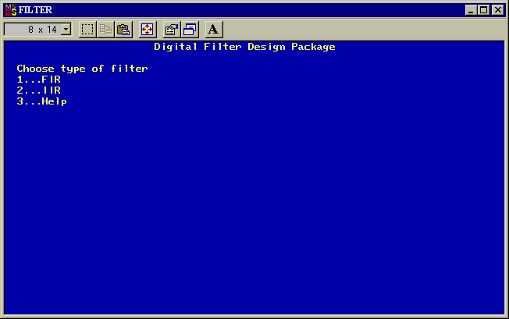

The user is able to select between FIR and IIR digital filters. Moreover, a help option is included in the program for assistance. In the help option, the basic theory of FIR and IIR filters is displayed by notepad in text form.

5.1.1 Specification of a FIR Filter

If the user selects to design a FIR filter then the filter.cpp program calls the fir.cpp program included in the accompanying disk. The following picture shows the output file of the fir.cpp program. This program is used to display the different methods that can be used for the design of the digital filter. As it can be seen there are three different choices for designing a FIR filter. The first two methods are based on the window technique. The difference between these two methods is that in the first one the user specifies the order of the filter whereas in the second one the program itself estimates the order of the filter. The last method is the optimal method and is based on the Remez Exchange Algorithm. Moreover, a help file is included again for assistance. In this help file the advantages and disadvantages of each method as well as the procedure for calculating the required filter coefficients is displayed.

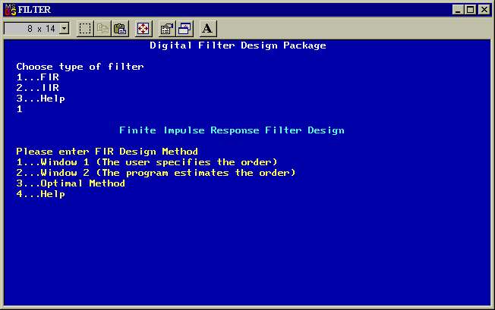

Specification for the Window Method

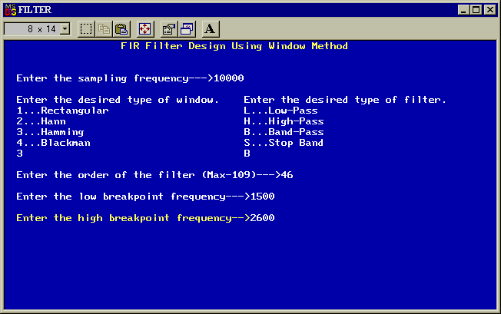
As it was previously stated there are two different programs for calculating the filter coefficients using the window method. If the first choice is selected the program window1.cpp is called by the fir.cpp program. The next picture shows a sample run of this program.

A flow chart of the filter specification using the first method is shown on page 16. The filter specification for this method includes the sampling frequency, the type of window (Rectangular, Hann, Hamming or Blackman), the function (low pass, high pass, band pass or band stop), the order and the breakpoint frequency(ies) of the filter. Moreover, the program checks the validity of the data entered by the user (e.g. if one of the breakpoint frequencies is greater than the Nyquist frequency or if the low breakpoint frequency of a band pass filter is greater than the high breakpoint frequency) and displays suitable warning messages.

If the second choice of the window method is selected then the program fir.cpp calls the window2.cpp program. A sample run of this program is shown in the picture below.

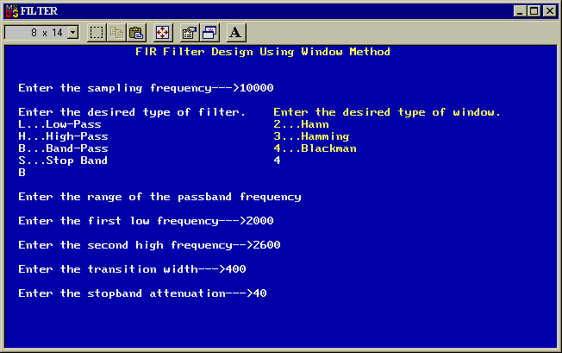
In this case, of which a flow chart of the program is given in figure 7, the user is asked by the PC to enter again the sampling frequency and select the function of the filter. The next steps is different compared to the previous case because the breakpoint frequency(ies), the transition width and the stopband attenuation are now required. When these parameters of the filter specification are specified then the program performs calculations in order to inform the user about which type of window can be used to achieve the required stopband attenuation. Moreover the program calculates the number of coefficients required for achieving the required attenuation for a specific transition width. The stopband attenuation for each type of window and the equations used for the calculation of the minimum order of the filter are shown in the next table.

Name of Window Function | Minimum Order of Filter | Stopband Attenuation  Maximum(dB)
Rectangular | 0.9/df | 21
Hann | 3.1/df | 44
Hamming | 3.3/df | 53
Blackman | 5.5/df | 74
For example if the user wants to design a low pass filter with sampling frequency of 8kHz, 0.5kHz transition width and 50dB stopband attenuation then the program will ask the user to select a Hamming or Blackman window, since stopband attenuation is 50dB. If the user selects to use a Hamming window then the program will calculate the minimum number of filter coefficients from the equations of the second column of the table. In the case of the Hamming window the program performs the following calculations:
$\text{df}=\frac{f_{c}}{f_{s}}=\frac{0\text{.}5\text{kHz}}{8\text{kHz}}=0\text{.}\text{0625}$$N=\frac{3\text{.}3}{\text{df}}=\text{52}\text{.}8≈\text{53}$

Specification Using Optimal Approximation Method

Because the window method suffers from the problem of finding a suitable approximation to a desired or ideal frequency response, the peak ripple occurs near the band edge, and decreases away from the band edge. It turns out that if the ripples were distributed more evenly over the passband and stopband a better approximation of the desired frequency response can be obtained. The optimal method is based on the concept of equiripple passband and stopband [5].

If the user selects to design a FIR filter using the Remez Exchange Algorithm then the fir.cpp program calls the remezrun.cpp program. The C code of this program included in the accompanying disk. A sample run of this program is shown on the picture below.

As it can be seen, the user enters the sampling frequency, the function of the filter, the breakpoint frequency(ies), the transition width, the stopband attenuation and the passband ripple of the filter. Then, the program proceeds by estimating the number of required filter coefficients. Before the program calculates the value of each coefficient a frequency response graph of the filter is displayed. If the user is satisfied with it then the program calculates the filter coefficients. If not, the user is able to increase or decrease the order of the filter for meeting the filter specification. All this procedure is repeated until the desired frequency response graph is displayed. Moreover, the program checks again the validity of the input data and if these are not correct suitable warning messages are printed on the screen.
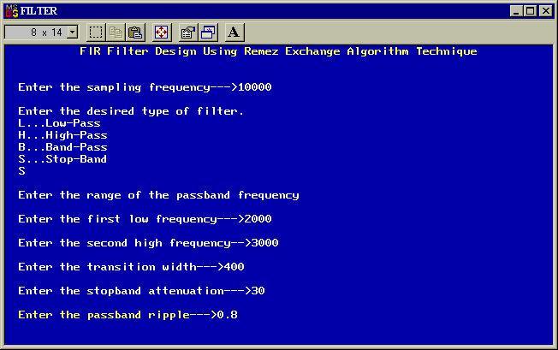
Enter the Sampling Frequency
Enter the type of Window
Enter the function of the filter
Enter the breakpoint frequency(ies)
Enter the order of the filter
Calculate Filter Coefficients
NO
YES

Figure 6. Flowchart of Specification using Window Method 1
Calculate Filter Coefficients
NO
Enter the Sampling Frequency
Enter the function of the filter
Enter the passband edge frequency
Enter the stopband attenuation
Enter the transition width
YES
Enter type of window
The program calculates filter coefficients

Figure 7. Flowchart of Specification using Window Method 2

Enter the Sampling Frequency

Enter the type of Window

Enter the function of the filter

Enter the order of the filter

Enter the breakpoint frequency(ies)

$f_{c}≤\frac{f_{s}}{2}$
NO

YES

Calculate Filter Coefficients

Figure 8. Flowchart of Specification using Optimal Method
5.1.2 Specification of an IIR Filter

The programs developed are able to design a digital filter by transforming an analogue low pass filter to the desired digital filter. The transformation of an analogue low pass filter to the desired digital filter is performed by the bilinear transformation method. What is required by this method is an analogue prototype function. The program calculates the required filter coefficients by using the Butterworth and Chebyshev approximations as prototype functions. The selection of the desired approximation is performed by the iir.cpp program. The code of this program is included in the accompanying disk and a sample run is shown in the picture below.
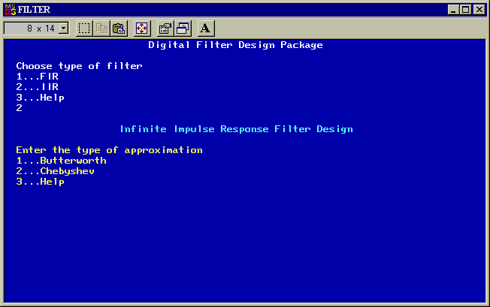

As it can be seen the user is able to choose between these two prototype functions and a help file. In this help file, the characteristics and the differences of these two approximations are listed.

If the user selects to implement an IIR digital filter using the Butterworth approximation then the iir.cpp program calls the butter.cpp program. The C code of this program is included in the accompanying disk and a sample run is shown on the next page. The program ask the user to enter the sampling frequency, the function of the filter and the breakpoint frequency(ies) and the order of the filter. The order of the filter can be entered by the user or can be found automatically by the program. In one hand the user enters the order of the filter and on the other hand the program calculates the order of the filter by asking the user to enter the frequency in which he wants to achieve the required stopband attenuation.

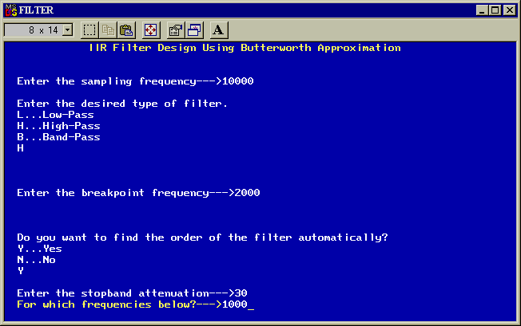
As far as the Chebyshev approximation is concerned the iir.cpp program calls the chebyshev.cpp program. The code of this program is included in the accompanying disk. The program asks the user to enter again the sampling frequency, the function of the filter, the breakpoint frequency and the order of the filter. Moreover the program ask the passband ripple in dB as it is a characteristic of a Chebyshev filter. A sample run of this program is shown below.

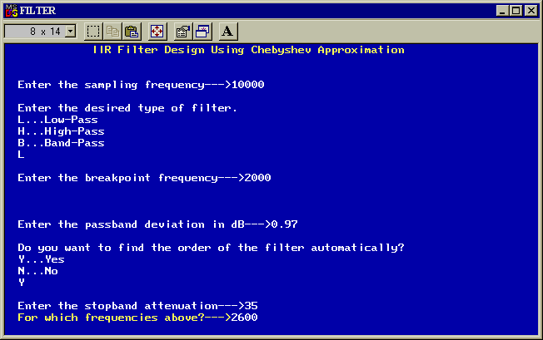
A general flow chart of these two programs is shown in the next figure.

Calculate Filter Coefficients
NO
Enter the Sampling Frequency
Enter the function of the filter
Enter the type of approximation
YES

Figure 9. Flowchart of Specification of a IIR Filter

Before the end of the filter specification a summary of the entered filter specification is displayed for confirming the suitability of the input data. The following picture shows a sample run of this summary for a FIR digital filter.
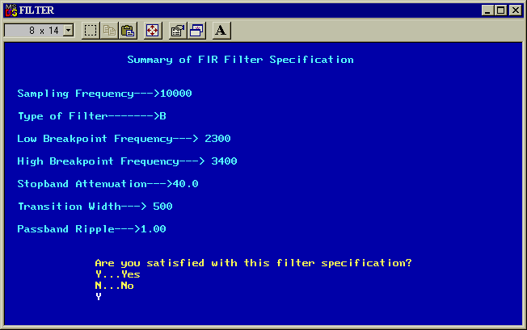

5.2 Calculation of the Filter Coefficients

5.2.1 Calculation of FIR Coefficients

The calculation of the coefficients for a finite impulse response filter is performed using three different techniques. The program developed in C calculates the filter coefficients using the window and the optimal method.

Calculation of the Ideal Impulse Response

$h_{D}\left(n\right)=\frac{1}{2π}\int{H_{D}\left(ω\right)e^{jωn}dω}$In this method, use is made of the fact that the frequency response of a filter, H_{D}(ω), and the corresponding impulse response, h_{D}[n], are related by the Inverse Fourier transform:

Solving this we can obtain the ideal impulse response of a low pass, high pass, band pass and band stop filter. Summarising the ideal impulse response for standard frequency selective filters is:

$h_{d[n]}=2f_{c}\frac{\text{sin}({nω}_{c})}{{nω}_{c}}$ i) Low pass

$h_{d[n]}=−2f_{c}\frac{\text{sin}({nω}_{c})}{{nω}_{c}}$
ii) High pass

- $h_{d[n]}=2f_{2}\frac{\text{sin}({nω}_{2})}{{nω}_{2}}−2f_{1}\frac{\text{sin}({nω}_{1})}{{nω}_{1}}$Band pass

$h_{d[n]}=2f_{1}\frac{\text{sin}({nω}_{1})}{{nω}_{1}}−2f_{2}\frac{\text{sin}({nω}_{2})}{{nω}_{2}}$
- Band stop

where f_{c}, f₁, f₂ are the passband edge frequencies, N the order of the filter and n≠0 [7].

The programs window1.cpp and window2.cpp are used to calculate the ideal impulse response. These programs calculate the filter coefficients using the above formulas for each value of n.

Window Method

Using this approach several practical problems are apparent. The most important of these is that although h_{D}[n] decreases as we move away from n=0, it carries to n=±∞. Thus, the resulting filter is not a FIR. A practical approach is to multiply the ideal impulse response, h_{D}[n], by a suitable window function, w(n), whose duration is finite. The resulting frequency response has the ripples and overshoots reduced. On the other hand the transition width is wider than the rectangular case. The transition width of the filter is determined by the width of the main lobe of the window. The side lobes produce ripples in both passband and stopband.

Several window functions have been proposed, each one having different advantages and disadvantages. The most common window functions and the main lobe relative to side lobe in dB are given in the next table [1].

Name of Window Function | Main lobe relative to side lobe (dB) | Window Function
$0\text{.}5+0\text{.}5\text{cos}\left(\frac{2πn}{N}\right)$Rectangular | 13 | 1
Hann | 31
$0\text{.}\text{54}+0\text{.}\text{46}\text{cos}\left(\frac{2πn}{N}\right)$Hamming | 41
$0\text{.}\text{42}+0\text{.}5\text{cos}\left(\frac{2πn}{N−1}\right)+0\text{.}\text{08}\text{cos}\left(\frac{4πn}{N−1}\right)$Blackman | 57

The main steps for calculating FIR coefficients using the window method are the following:

- Specify the ideal or desired frequency response of the filter, H_{D}(ω).

- Obtain the impulse response, h_{D}[n], of the desired filter by evaluating the inverse Fourier transform. The expressions for h_{D}[n] were summarised previously.

- Select a window function that satisfies the passband or attenuation specifications and then determine the number of filter coefficients using the appropriate relationship between the filter length and the transition width, df.

- Obtain values of w(n) for the chosen window function and the values of the actual FIR coefficients, h_{D}[n], by multiplying h_{D}[n] by w(n):

$h\left[n\right]=h_{D}[n]⋅w\left(n\right)$

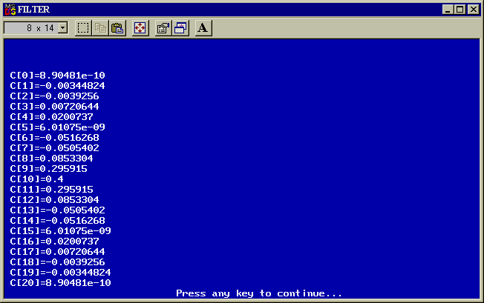
The programs window1.cpp and window2.cpp are used for the calculation of the impulse response. These programs calculate the impulse response of the desired filter, the values of w(n) for the chosen window function and then multiply them together. The values obtained are the required filter coefficients of a FIR digital filter. The C code of these programs is included in the accompanying disk. A sample run of these programs is shown in the picture below. The FIR coefficients obtained, are for a 20th order low pass filter with 10kHz sampling frequency and 2kHz breakpoint frequency using a Hamming window.

Optimal Approximation

As it was previously stated better results can generally be obtained with the optimal approximation method. This method designs a linear-phase FIR filter using the Parks-McClellan algorithm. The Parks-McClellan algorithm uses the Remez exchange algorithm and Chebyshev approximation theory to design filters with an optimal fit between the desired and actual frequency responses. The filters are optimal in the sense that the maximum error between the desired frequency response and the actual frequency response is minimised. Filters designed this way exhibit equiripple behaviour in their frequency responses and hence are sometimes called equiripple filters.

In the optimal method, the objective is to determine the filter coefficients, h(n), in order to minimise, the maximum weighted error |E(ω)|, in the passband and stopband. It has been proved that when the weighted error |E(ω)| is minimised the resulting filter response will have equiripple passband and stopband. The minima and maxima are known as extremal frequencies. For linear phase filters, there are n+1 or n+2 extremal frequencies, where:

$n=\frac{N+1}{2}$
for type 1 filters

$n=\frac{N}{2}$
for type 2 filters

The main problem in the optimal method is to find the locations of the extremal frequencies. Using the Remez exchange algorithm the locations of the extremal frequencies are easily found. Knowing the locations of the extremal frequencies, it is very simple to work out the actual frequency response and hence the impulse response of the filter. For a given set of specifications the optimal method involves the following key steps [5].

- Use the Remez exchange algorithm to find the optimum set of extremal frequencies.

- Determine the frequency response using the extremal frequencies.

- Obtain the impulse response coefficients.

Obviously, the key step of the optimal process is the first step where an iterative process is used to determine the extremal frequencies of a filter whose frequency response satisfies the number of extremal frequencies that can exist for a given value of N. A simplified flow chart of the optimal method that was used for the development of the program is given in the next figure.

Filter Specification
Initial guess of n+1 extremal frequencies
Determine |E(ω)| and its largest n+1 extremal frequencies
Obtain the impulse response coefficients
Extremal frequencies changed
Yes
No

Figure 10. Calculation of Filter Coefficients Using Optimal Method

The main program that is used to calculate the required filter coefficients is the remezrun.cpp. In this program the user enters the filter specification and in particular the function of the filter. Depending on the function of the filter the remezrun.cpp program calls different programs such as remezlow.cpp, remezhigh.cpp, remezband.cpp and remezstop.cpp. If the user selects to design a low pass filter then the remezlow.cpp program will be called by the remezrun.cpp. Because the Remez Exchange algorithm calculates the filter coefficients dividing the frequency response into bands, the main difference of these programs is the value of the weight of each band and the length of each band. The weight of each band is found by the ratio of the passband to stopband ripples expressed in ordinary units. The code of these programs is included in the accompanying disk. A sample run of the program is shown on the next page. The program calculates the coefficients for a low pass filter with 10kHz sampling frequency, 2.4kHz breakpoint frequency, 40dB stopband attenuation, 900Hz transition width and 0.8dB passband ripple.

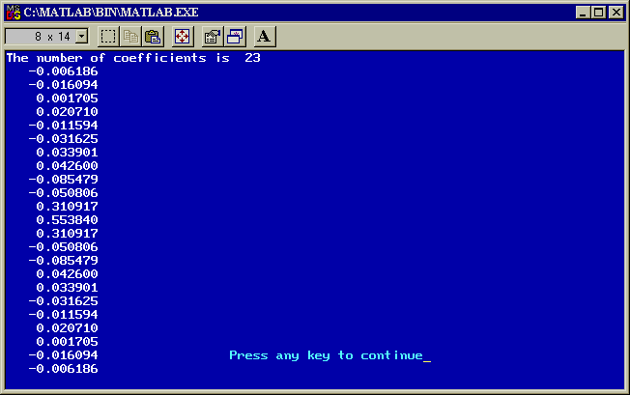

5.2.2 Calculation of IIR Coefficients

Starting from the desired digital filter specification, the low pass analogue specification is obtained. Then an analogue low pass filter is designed to meet the filter specification. Finally, the desired digital filter is obtained by transforming H_{a}(s) to H(z). There are several types of transformation. The all around best and the one is used in the system is the bilinear transformation.

The basic steps for calculating digital filter coefficients using the bilinear method are the following.

- Use the digital filter specification to determine a suitable normalised transfer function, H(s).

- Determine the cut-off frequency of the digital filter.

- $ω_{p}^{'}=k\text{tan}\left(\frac{ω_{p}T}{2}\right)$Obtain an equivalent analogue filter cut-off frequency using the following relation (prewarped)

- $ω_{p}^{'}$Denormalise the analogue filter by frequency scaling H(s). This is achieved by replacing s with s/ .

- $2⋅\frac{z−1}{z+1}$Apply the bilinear transformation to obtain the desired digital filter transfer function H(z) by replacing s by .

Design Using Bilinear Transformation

Before applying the bilinear transformation the transfer function of an Nth order filter is required. The two basic types of analogue filters that can be used as prototype for designing IIR filters are listed below.

H(s) for Butterworth approximation
$H\left(s\right)=\frac{1}{\left(1+s\right)⋅\prod_{k=1}^{\left[\frac{n}{2}\right]}{\left\{1+2⋅\text{sin}\left[\left(2⋅k−1\right)\frac{π}{2⋅n}\right]⋅s+s^{2}\right\}}}$

H(s) for Chebyshev approximation
$H\left(s\right)=\frac{1}{{\left(1+\frac{s}{μ}\right)}^{l}⋅\prod_{k=1}^{\left[\frac{n}{2}\right]}{\left[1+\frac{2μ⋅s_{k}⋅s}{u_{k}}+\frac{s^{2}}{u_{k}^{2}}\right]}}$

$μ=\text{sinh}\left[\left(\frac{1}{n}\right){\text{sinh}}^{−1}\left(\frac{1}{e}\right)\right]$$λ=\sqrt{\left(1+μ^{2}\right)}$$s_{k}=\text{sin}\left[\left(2k−1\right)\frac{π}{2n}\right]$
where , ,

$u_{k}=μ^{2}+1−s_{k}^{2}$and

In the third step we determine and prewarp the critical frequencies of the filter. If we have a low pass filter there is only one critical frequency, ω'_{p}. In the case of a band pass or a band stop filter we have the lower and upper critical frequencies, ω'₁,ω'₂.

In the fourth step if we replace the s by s/ω’_{p} we obtain an IIR filter with low pass characteristics. We can obtain IIR filters with different characteristics if we choose another replacement for s. There are the following transformations:

$s=\frac{s}{ω'_{p}}$
low pass to low pass

$s=\frac{ω'_{p}}{s}$
low pass to high pass

$s=\frac{s^{2}+P^{2}}{D}$
low pass to band pass

$s=\frac{D}{s^{2}+P^{2}}$
low pass to band stop

where P²=ω'₁ω'₂ and D=ω'₂-ω'₁
In the bilinear transformation, the variable s in H_{a}(s) is replaced with a bilinear function of z to obtain H(z). If we use direct replacement of s with z this may lead to undesirable response. The transformation that is always used is the following:
$s=k\frac{z−1}{z+1}$$\frac{2}{T}$
, k=1 or

Before applying the bilinear transformation the transfer function of an Nth order filter is required [5]. The two basic types of analogue filters that can be used as prototype for designing IIR filters are listed below.

All this procedure is provided by the C programs butter.cpp and chebychev1.cpp that are called by the iir.cpp program. These programs determine the transfer function depending on the filter specification and apply the bilinear transformation. At the end of these programs second order filter sections are calculated. For example if the specifications of the filter is to design a second order Butterworth-type IIR low pass filter with ω_{c}=π/4 then the program will calculate the analogue Butterworth low pass filter with cut-off frequency 1radian/second:

$H_{a}\left(s\right)=\frac{1}{1+\sqrt{2}⋅s+s^{2}}$

$Ω_{c}=2⋅\text{tan}\left(\frac{π}{8}\right)=0\text{.}\text{828}$
The prewarped frequency is

$2\frac{z−1}{z+1}$
By replacing s by s/0.828 and then s by we obtain:

$H\left(z\right)=\frac{z^{2}+2⋅z+1}{\text{10}\text{.}3⋅z^{2}−9\text{.}7⋅z+3\text{.}4}=0\text{.}\text{097}\frac{1+2⋅z^{−1}+z^{−2}}{1−0\text{.}\text{94}⋅z^{−1}+0\text{.}\text{33}⋅z^{−2}}$

If the user designs a low pass or high pass the whole procedure is straightforward. The main problem is that the band pass and stop band transformations produce a fourth order transfer function from each second order section. These fourth order sections are re-expressed as the product of two second order transfer functions. This re-expression can be performed by the Geff's algorithm, which provides two second order sections.

The C code for these programs are included in the accompanying disk. A sample run of these programs is shown on the next page. The program calculates a 4th order low pass filter with 8kHz sampling frequency and 500Hz breakpoint frequency using the Butterworth approximation.

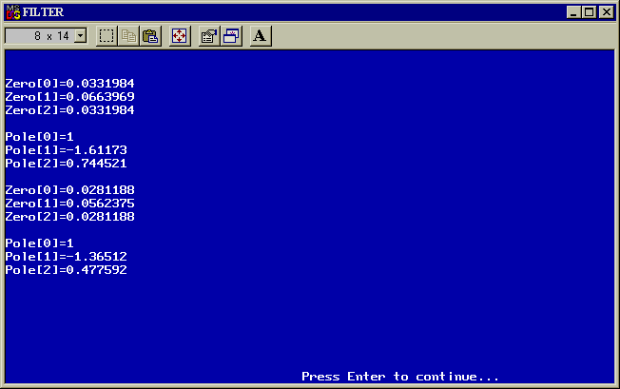

5.3 Display of the Frequency Response Graph

The frequency response graph of the designed digital filter is plotted by MatLab. MatLab is a high level computing language with facilities for matrix operations and complex calculations. The signal processing toolbox of MatLab includes many powerful, classical algorithms for processing digital signals including

- altering frequency content
- analysing frequency content
- extracting features.

These tools are essential part of many applications including audio, video, communications etc. Moreover, MatLab provides the user with an accurate depiction of the frequency response of the filter in graph form.

The display of the frequency response graph is performed by the signal processing toolbox of MatLab. The signal processing toolbox of MatLab offers a variety of functions known as MEX files. Many different functions are used for the display of the frequency and phase response depending on the filter specification.

When the filter specification is defined the program generates a M-file based on it. This file is saved by the name of startup.m. It is necessary the file to be saved with the specified name because each time MatLab is loaded then the PC is looking for a file with this name. If there is a file with this name then this file is running automatically.

5.3.1 Display of a FIR Filter Frequency Response Graph

As it was previously stated, the design of a FIR filter is based on the window and the optimal approximation method. Thus, two different programs were developed for each case.

Display of Graph using Window Method

In the case of the window method there is a general form of a file that is generated. For example if we want to design a 20th order FIR low pass filter using a Hamming window with 10kHz sampling frequency and 3kHz cut-off frequency then the following M-file is generated by the C program.

w=hamming(21);
for n=1:21;
a(n)=0.6000*sinc((n-11)/1.667)*w(n);
end;
h=freqz(a,1,1000);
whitebg('k');
plot([0:999]/1000,20*log10(abs(h)),'r');
axis([0,1,-80,7]);
grid on
title('Frequency Response Graph of a Low pass Filter using Hamming Window');
xlabel('Relative Frequency / Pi');
ylabel('Gain(dB)');
clear

The characters in bold are the parts of the M-file that change depending on the filter specification. The following graph is the output of the previous M-file.

The M-file of a 20th order high pass filter with sampling frequency of 10kHz and cut-off frequency of 3kHz using a Blackman window and the corresponding graph are shown below.

w=blackman(21);
for n=1:21;
a(n)=(0.6000*sinc((n-11)/1.667)-sinc(n-11))*w(n);
end;
h=freqz(a,1,1000);
whitebg('k');
plot([0:999]/1000,20*log10(abs(h)),'r');
axis([0,1,-80,7]);
grid on
title('Frequency Response Graph of a High pass Filter using Blackman Window');
xlabel('Relative Frequency / Pi');
ylabel('Gain(dB)');
clear

The characters in bold are the parts of the M-file that change depending on the filter specification.

The M-file of a 30th order band pass filter with 16kHz sampling frequency, 3kHz low breakpoint frequency and 5kHz high breakpoint frequency is shown below.

w=hanning(31);
for n=1:31;
a(n)=(0.6250*sinc((n-16)/1.600)-0.3750*sinc((n-16)/2.667))*w(n);
end;
h=freqz(a,1,1000);
whitebg('k');
plot([0:999]/1000,20*log10(abs(h)),'r');
axis([0,1,-80,7]);
grid on
title('Frequency Response Graph of a Band pass Filter using Hanning Window');
xlabel('Relative Frequency / Pi');
ylabel('Gain(dB)');
clear

The characters in bold are the parts of the M-file that change depending on the filter specification.

Display of Graph Using Optimal Method

The graph of the digital filter using the optimal method is plotted using the following M-file. The remez function is used in this M-file and its structure is A=REMEZ(N,F,A). This function returns a length N+1 linear phase (real, symmetric coefficients) FIR filter which has the best approximation to the desired frequency response described by F and A in the minimax sense. F is a vector of frequency band edges in pairs, in ascending order between 0 and 1. 1 corresponds to the Nyquist frequency or half the sampling frequency. The following MatLab program designs a low pass filter, sampled at 10kHz, whose gain is specified to be unity (0dB) in the range of 0 to 2kHz and 0 in the range 3kHz to 5kHz. The gain in the transition band is not specified. For low pass and high pass filters there are two transitions bands as shown below.

a=remez( 18,[0 0.400, 0.600, 1],[1, 1, 0, 0]);
h=freqz(a,1,1000);
whitebg('k');
plot([0:999]/1000,20*log10(abs(h)),'y');
axis([0,1,-50,5]);
grid on;
title('Frequency Response Graph of a Low pass Filter having 19 coefficients');
xlabel('Relative Frequency / Pi');
ylabel('Gain(dB)');
clear

The characters in bold are the parts of the M-file that change depending on the filter specification.

In the case of the design of a band pass or band stop filter the specified bands are not two pairs as in the case of the low pass or high pass filter but three. The following M-file is used for plotting a band pass filter, sampled at 10kHz, having 2kHz, 4kHz and 800Hz, low and high passband edge frequencies and transition width respectively. The passband ripple is 0.5dB and the stopband attenuation 30dB.

a=remez( 14,[0 0.240 0.400 0.800 0.960 1],[0, 0, 1, 1, 0, 0]);
h=freqz(a,1,1000);
whitebg('k');
plot([0:999]/1000,20*log10(abs(h)),'y');
axis([0,1,-50,5]);
grid on;
title('Frequency Response Graph of a Band pass Filter having 15 coefficients');
xlabel('Relative Frequency / Pi');
ylabel('Gain(dB)');
clear

The characters in bold are the parts of the M-file that change depending on the filter specification

5.3.2 Display of IIR Filter Frequency Response Graph

The main difference between the FIR and IIR digital filter is that FIR can have linear phase response whereas IIR don't. Thus, in displaying the characteristics of an IIR filter we have to plot not only the frequency response but also the phase response of the filter.

As it was previously stated, the design of an IIR filter is based on the choice of an analogue prototype. In the case where a Butterworth or Chebyshev analogue filter is selected the Butter or Cheby1 function is used. The syntax of these commands is the same for both cases. For example the Butter function [B,A] = BUTTER(N,Wn) designs an Nth order low pass digital Butterworth filter and returns the filter coefficients in length N+1 vectors B and A. The cut-off frequency Wn must be 0.0 < Wn < 1.0, with 1.0 corresponding to half the sample rate. Moreover, in order to plot the phase response graph the freqz function is used. Its syntax is H = FREQZ(B,A,F,Fs) given sampling frequency Fs in Hz returns the complex frequency response at the frequencies designated in vector F, also in Hz.

For example if we want to design a 4th order low pass Butterworth filter, sampled at 10kHz, with 2kHz breakpoint frequency then the following M-file is generated.

[a,b]=butter(4,0.400);
freqz(a,b,1000,10000);
title('Frequency and phase response of a 4th order Butterworth Low pass Filter');

In addition, the user is able to select many different plots such as Argand diagram and impulse response. The MatLab function zplane is used for the plot of the Argand diagram. Zplane(z,p) plots the zeros Z and poles P (in column vectors) with the unit circle for reference. Each zero is represented with a 'o' and each pole with a 'x' on the plot. Moreover the impulse response graph is plotted by the impz function. IMPZ(B,A) computes the impulse response of the filter with B and A being the coefficients of the IIR filter.

For example if we want to design a 6th order low pass Butterworth filter, sampled at 10kHz, with 2kHz breakpoint frequency then the following M-file is generated.

[a,b]=butter(6,0.400);
subplot(2,2,1);
freqz(a,b,1000,10000.0);
subplot(2,2,3);
zplane(a,b);
title('Argand Diagram');
subplot(2,2,4);
impz(a,b);
title('Impulse Response');

5.4 Implementation of the Filter

Having calculated the filter coefficients, chosen a suitable structure, the difference equation must be implemented. In real time processing, the filter is required to operate on the present input sample, x[n], to produce the current output sample, y[n], before the next input sample arrives, that is within the intersample period. Real time filtering requires fast hardware if the sample rate is very high or if the filter is of a high order. Because the designed digital filters will be applied to audio applications, the TMS320C30 microprocessor will be adequate.

The software code that could implement the filtering could be written in C or assembly. Even if the writing of a C code seems to be easier than writing in assembly the execution time of both codes should be considered. It is verified that the TMS320C30 code filter is executed slightly faster than its C version. Therefore, the assembly code was preferred in order to achieve higher order of filters and faster sampling rates. In a FIR filter the maximum order of filter that can be implemented is 109, whereas in an IIR is 9.

The assembly program is generated by the finite.cpp and infinite.cpp programs for a FIR and IIR filter respectively. When the user defines the filter specification and the filter coefficients are calculated this program generate the proper assembly code necessary to implement the filtering depending on the order of and the type of the filter. This code is compiled and linked in the DSP card by the fir.cpp and iir.cpp programs.

Setting the Input Serial Port

Alternative input devices can be connected through the TMS320C30 serial port 0. In our applications the signal is fed into the serial port 0. The program, which implements the filtering, calls the program aiccoma.asm, which is listed in the appendices. This program is a standard AIC communication program that is used to specify the input serial port, capture the input sample and transfer it into the main program. As it can be seen from the program, in order to access the serial port 0 the content of SPSET must be set 0. The AIC configuration data with AICSEC is set for a sampling rate of 10kHz [7]. Different sampling rates can be achieved by changing the AIC configuration with a maximum of 19.2kHz.

5.4.1 FIR Implementation

The implementation of the filtering is done by a standard assembly program. The difference between different FIR filters designs is the order of the filter and the value of the coefficients. The whole procedure of filtering is based on circular buffering. A circular buffer is necessary to implement delays associated with convolution. The program used for the implementation of a low pass filter, with 10kHz sampling frequency, 2kHz breakpoint frequency, 1kHz transition width and 30dB stopband attenuation, is shown in the appendices.

A detailed description of the program follows:

- XN_ADDR specifies the bottom address of the samples reserved for x[n]. HN_ADDR specifies the starting address of the coefficient table.

- The input and output address are loaded into R6 and R7 respectively. The filter length is loaded in AR4 and into the special register BK, which specifies the size of the circular buffer for the samples. AR4 is used as loop counter.

- AR1 and AR0 are loaded with the bottom address of the sample x[n], and the starting address of the coefficient table respectively.

- The instruction FLOAT R6,R3 is to input a sample. This sample is converted to its floating point equivalent R3, then stored at the last address in the sample table, reserved for x[n]. AR1 is then postincrement to point at the top or first address in the sample table. AR0 is loaded with the starting address of the coefficient table.

- The multiply operation is executed in parallel with the next ADDF addition operation, a total number of length times. The result of each multiplication is stored in R0. Then R0 is accumulated into R2.

- The instruction DBNZD AR4,LOOP causes the AR4 to be decrement and tested for a nonzero condition. The last three steps are repeated to access a new sample and calculate a new output value. This loop is executed AR4+1 times.

5.4.2 IIR Implementation

The implementation of an IIR filter is also performed by a standard assembly program. Changing the order of the filter and the value of the coefficients, we can obtain different IIR designs. The assembly code that is used in the case of a IIR filter is shown in the appendices. This program is used to design a 6th order bandpass filter. The structure used consists of three second order sections in cascade. For each stage there are three a and two b coefficients.

A description of the program follows:

- The input and output address are loaded into R6 and R7 respectively.

- AR1 and AR0 are loaded with the bottom address of the sample x[n], and the starting address of the coefficient table respectively.

- The newest input sample is stored in R3. Initially AR0 points at the starting address of the coefficient table that contains the first coefficient and AR1 points at the x[n-1]. The first multiply operation calculates:
$R0=b_{1}x\left[n−1\right]$

and then AR0 and AR1 are increment to point the second coefficient and x[n-2] respectively.
The second multiplication calculates:
$R1=b_{2}x\left[n−2\right]$

Because it is in parallel with a subtract instruction then:
$R3=x\left[n\right]−b_{1}x\left[n−1\right]$

and AR0 is incremented to point a₁, and AR1 is decrement to point back the input x[n-1].
The third multiply operation calculates:

$R0=a_{1}x\left[n−1\right]$

The subtract instruction in parallel gives:
$R2=x\left[n\right]−b_{1}x\left[n−1\right]−b_{2}x\left[n−2\right]$

The fourth multiplication calculates:

$R1=a_{2}x\left[n−2\right]$

and the addition gives:

$R3=a_{1}x\left[n−1\right]+a_{2}x\left[n−2\right]$

The fifth multiply instruction calculates:
$R2=a_{0}x\left[n\right]$

The last multiply instruction calculates:

$R0=b_{1}x\left[n−1\right]$

and the addition in parallel gives the output.

- After each output sample, branching back to the function IIR occurs with delay, with the instruction DBNZD AR3,IIR. AR3, which contains the number of samples minus 1, is decrement. Branching occurs as long as AR3 is not zero. The condition is first tested for branching and then AR3 is decrement.

Assembling and Linking

When the assembly code is written is necessary to compile it checking for errors. If the assembly code is correct then the next step is to link it. This creates an output file, which is then downloaded to the DSP card. This creates an output file, which is then downloaded to the DSP card. It is more appropriate to specify the output file within a user-defined command file. This command file is called tms.cmd and is listed in the appendices. Within this command file, the user can specify where various sections of the code are to be stored in memory [7]. A standard command file that is used for the implementation of the filtering is shown at the appendices. The compilation and linking is performed by using the following command:

cl30 -o2 c:\filter\tms.asm -z c:\filter\tms.cmd

6. Results

As it was previously stated, the AIC of the TMS320C30 card has programmable sampling rates with a maximum sampling rate of 19.2kHz. Because of this sampling rate this AIC is suitable for voice band signals. A series of experiments were performed to determine the correct operation of the system. Thus, a range of different types of input signals was tested.

The procedure followed was that by entering different filter specifications, different outputs were expected. Moreover, the frequency response graph of the filter was obtained to verify the output response. These signals were tested using both FIR and IIR digital filters.

The type of signals tested was sinusoids. The author entered a filter specification, the program calculated the filter coefficients and downloaded the assembly code to the DSP card. Then, using the signal generator as the signal source, the frequency of signal was altered. When the signal was at frequencies specified in the passband at the filter specification, the output of the DSP card was not changed as it was observed from the CRO. On the other hand, if the frequency was at the stopband the output of the DSP card was very close to zero. In addition, the output of the DSP card was as predicted by the frequency response graph. The output was in agreement not only with the displayed frequency response but also with the phase response. Furthermore, the equiripple that was expected using the Remez Exchange Algorithm in the stopband and passband and in the case of a Chebyshev filter in the passband was noticed in the CRO.

Because this programmable real time digital filter will be used for laboratory purposes one of the main concerns was the development of a user friendly and convenient program. The program developed is not only a system that could be used by experts but also by people with inadequate educational background in digital filters. This is provided by help files that can be through the design of a digital filter. Moreover, the validity of the input data is checked by the program. Thus, if correct input data is not entered then the PC displays suitable warning messages.

7. Future Development

The system can be used for the implementation of FIR and IIR digital filters. The techniques used in the case of a FIR filter are the most commonly used ones. A future development of the system could be the implementation of IIR filters using different analogue prototype functions. In this system, the Butterworth and Chebyshev approximations were used. However, the Inverse Chebyshev and Elliptic approximations could be easily used. This can be readily achieved because the C code has be written in such a way that only a few lines of code have to be changed. These lines of code are used for the generation of the second order filter section of the analogue prototype function. Thus, if we change these lines with the general formula of Inverse Chebyshev and Elliptic approximations then the system can implement these functions as well.

8. Conclusion

The designed system is able to implement both FIR and IIR digital filters. It is able to implement FIR filters using the window method and the optimal method based on the Remez Exchange Algorithm, as well as IIR filters using the bilinear transformation method. The bilinear transformation is used to convert Butterworth and Chebyshev analogue prototypes into digital filters. Experiments conducted showed that the resulted frequency and phase response of the filter was in agreement with both the user specification and the displayed frequency response.

The current great interest and developments in DSP are likely to continue for the near future. The availability of digital signal processors recognises the commercial potential of DSP. Its major attraction lies in the ability to achieve guaranteed accuracy and perfect reproducibility, which is a major advantage compared to the analogue systems. The signal filtering is only one example of using digital instead of analogue systems to achieve our goal. It is certain that in the near future the DSP systems will play an important role in the development of the technology replacing many analogue systems that are used up to now.

9. References

[1] Emmanuel C. Ifeachor and Barrie W. Jervis, Digital Signal Processing, A Practical Approach, Addison-Wesley, 1993.

[2] Leland B. Jackson, Digital Filters and Signal Processing, Kluwer Academic Publishers, 1986.

[3] Leland B. Jackson, Digital Filters and Signal Processing (3rd Edition), Kluwer Academic Publishers, 1995.

[4] R.W. Hamming, Digital Filters (2nd Edition), Prentice-Hall Signal Processing Series, 1983.

[5] Jerry C. Whitaker, The Electronics Handbook, CRC Press and IEEE Press, 1996

[6] Texas Instruments, TMS320C30 User's Guide, Texas Instruments, Inc., Dallas, Texas, 1989.

[7] Rulph Chassaing, Digital Signal Processing with C and the TMS320C30, Wiley- Interscience, 1992.

[8] Byron S. Gottfried, Programming with C, McGraw-Hill, 1990

[9] Stephen C. Dewhurst and Kathy T. Stark, Programming in C++, Prentice Hall Software Series, 1989

[10] Antoinette M. Wilkinson, The Scientist's Handbook for Writing Papers and Dessertations, Prentice Hall, 1991

